**Leader Overview**



**Volume Overview**

**Expect the Unexpected**

*We all make plans—plans for where we’re going and what we want to do. But life is more often a story of unexpected interruptions. Our faith helps us to recognize God’s hand at work in unanticipated ways. By faith we learn to embrace life’s interruptions as the place God so often does miraculous things. We learn to respond with compassion and faith when things seem impossible.*

**Session Overview**

**Keep the Faith**

*In this* **Live** *session, kids will discover how one man held onto his faith that Jesus could heal his daughter, even when others doubted. Kids will learn to hold on tightly to their faith in Jesus too, even when they confront the impossible. Following Jesus doesn’t mean things are always easy, but we can always trust in Him.*

**Bible Lesson**

A Religious Leader’s Daughter Is Raised from the Dead

[Mark 5:21–24](https://ref.ly/logosref/Bible.Mk5.21-24), [35–43](https://ref.ly/logosref/Bible.Mk5.35-43)

**Faith Fact**

I will trust Jesus even if it’s hard.

**Faith Verse**

[Proverbs 3:5–6](https://ref.ly/logosref/Bible.Pr3.5-6) (NLT)

Trust in the Lord with all your heart; do not depend on your own understanding. Seek his will in all you do, and he will show you which path to take.

**Preparing for the Session**

**Leader Preparation Time: 20–25 Minutes**

|  |
| --- |
| ***You Will Need***  ***Large Group***   * *Bible* * *Worship songs (Song suggestions: “Way Maker” by Leeland; “Surrounded (Fight My Battles)” by Bethel Music; “Battle Belongs” by Phil Wickham; “Zeal” Lyric Video by The Belonging Co)* * *For groups not using a phone or tablet only, add:Projector or TV*   *• Laptop*  *•* ***Faith Fact Slide***  ***• Faith Verse Video*** *or* ***Slide***  ***• Bible Lesson Video***  ***• Teaching Point Slides 1–3***   * *Blindfold* * *Candy bar* * *Index cards, one per kid* * *Pens or pencils, one per kid* * *Basket*   ***Small Group***   * *Yarn or string* * *Scissors* * *Bibles for kids in the group to share* * *Ball, one per group* * *Large space to play in* * ***Small Group Activity Page****, one per kid* * *Pencils or pens, one per kid* * *Crayons or markers*   *To access session content and videos from a computer, visit:* [*BibleEngagementProject.com/downloads*](https://bibleengagementproject.com/downloads) |
| ***Getting Ready***  ***Large Group***   * *Download videos and slides if needed.* * *Select worship song(s) and have them ready to play.* * *Read the Bible Lesson Scripture to prepare for Teaching Time.*   ***Small Group***   * *Cut yarn into approximately two-foot lengths, one piece per kid.* * *Print copies of the* ***Small Group Activity Page****, one per kid.*   *First time leading* Live *for Kids? Check out the* [*Facilitator Guide*](https://0b769b0ed3569ef9d18b-f88d8272f61086866d50d048b43ef630.ssl.cf2.rackcdn.com/sites/biblengagementproject/Listen_Facilitator_Guide.pdf)*.* |

**Large Group**

**30 Minutes**

*See what’s needed at the beginning of the session.*

**Introduction**

I’m so glad you joined me today! We’re going to talk about one of the most unexpected things Jesus did when He was living on the earth. Some people would say what Jesus did in this Bible story is completely impossible, but it really did happen. Remember, every story in the Bible is true! The amazing miracle we’ll talk about today happened when someone held tightly to their faith in Jesus—even when their problem seemed too big to fix. Have you ever gone through a really difficult time? *(Group response)*

• *Tell a personal story about a time when you faced something difficult. Share if it made you question God or struggle with your faith. Try to keep it something kids can relate to if possible.*

**Faith Fact**

It’s a lot easier to trust Jesus and believe He is there for you when everything is going well in your life. Do you agree with that? *(Group response.)* But true faith in Jesus requires us to trust Him all the time, even when things get hard and nothing’s going our way. That’s why our Faith Fact today is **I will trust Jesus even if it’s hard.**

• *Show the* ***Faith Fact Slide.***

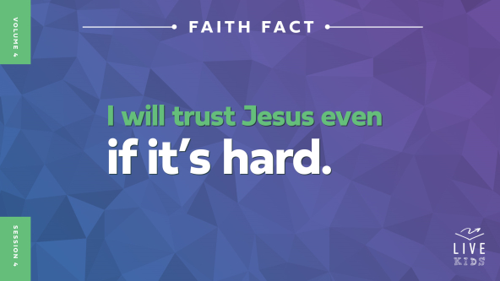

Let’s say the Faith Fact together while we stomp our feet on every word. Are you ready? *(Group response)* **I will trust Jesus even if it’s hard.** One more time. **I will trust Jesus even if it’s hard.**

**Game**

**Trust Challenge**

Trusting Jesus is easy when things are going well. But what happens when things get complicated or hard? Some people start to doubt that Jesus is there. Maybe they wonder if He’s listening. Yes, Jesus is always with us, and He’s always listening—but that doesn’t mean life won’t be difficult sometimes.

Today’s game is a trust challenge. Everyone choose a partner. You’ll be trusting each other. I’ll give you several challenges, and each time, only one of you gets to compete. If you can’t do the challenge, both you and your partner are out of the game. Let’s take this trust challenge together! Are you ready? *(Group response)*

• *Let kids pair up and choose which of them will complete the first challenge. Have kids take turns completing the challenges as you give them.*

• *Announce a new a trust challenge for each round. Ideas: run in place for 30 seconds, recite the alphabet, do 20 jumping jacks, sing “Happy Birthday,” do 10 push-ups, say the Faith Verse, do a cartwheel, do a headstand, say the names of the books of the New Testament in order, etc.*

• *After each round, determine which teams didn’t complete the challenge and have them sit down.*

Some of those trust challenges were really hard. You or your partner might have even failed at one of them. That’s okay. The great news is that even when other people let us down, Jesus is still with us. We can always put our trust in Him.

**Worship**

Something that always helps us through a hard time is worshipping God. There’s something about praising God in the middle of something hard that makes your worship even more powerful. You’re telling God that He’s still worthy of your worship whether your prayers have been answered the way you wanted or not. Let’s worship Him right now—no matter what we’re going through.

• *Lead the kids in singing one or two praise songs. See suggestions at the beginning of the session.*

**Bible Lesson**

Worship can change our point of view, our way of thinking. Why? Because worship helps us focus on Jesus instead of our problem. That’s what the man in our Bible story had to do. His situation seemed hopeless, but he kept his focus on Jesus. He kept trusting Jesus. Before we find out what Jesus did for the man, let’s pray and ask Jesus to strengthen our faith in Him today.

**Prayer**

|  |
| --- |
| *Dear Jesus, thanks for always being there for us, even when we face hard times. Help us grow in our faith today and keep our focus on You. Amen.* |

**Video Intro**

Just before we look at the Bible story, let’s watch this video.

• *Play* ***Bible Lesson Video****.*



**Bible Story**

**A Religious Leader’s Daughter Is Raised from the Dead**

Are you ready to learn more about the totally unexpected thing Jesus did in today’s story? *(Group response)* Most of us want to see Jesus do miracles in our life, but we don’t want to deal with the hard times that come before the miracle. Think about it. Jesus doesn’t need to do a miracle in your life if everything is already good. We might even think we don’t need Jesus’ help when things are going well. But the truth is, we always need Jesus’ help, no matter what.

**Teaching Time**

A religious leader named Jairus had a big problem. His twelve-year-old daughter was dying. Jairus knew that he needed Jesus to do a miracle and heal his daughter. He knew he needed to trust Jesus even though he was probably feeling scared and sad. That’s what our Faith Fact reminds us about. Say it with me. **I will trust Jesus even if it’s hard**. Grab your Bible or pull up a Bible app on your device. Turn to [Mark 5:21–24](https://ref.ly/logosref/Bible.Mk5.21-24), [35–43](https://ref.ly/logosref/Bible.Mk5.35-43).

• *In order to keep Large Group time moving along, we recommend that the leader reads the Scripture portions aloud.*

• *Optional: Remind the kids to mark this place with a bookmark, so they can read it on their own at home.*

1. **Jairus had faith that Jesus could do the impossible.**

• *Show the* ***Teaching Point 1 Slide.***

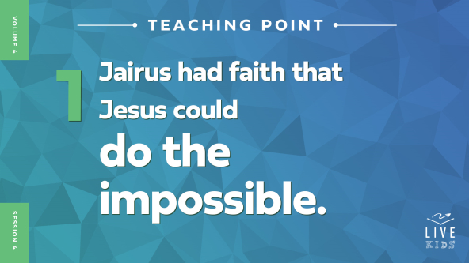

• *Read* [*Mark 5:21–24*](https://ref.ly/logosref/Bible.Mk5.21-24)*.*

Jesus traveled a lot. He walked from one town to another, doing miracles, casting out demons, and healing people who were sick. Do you think Jesus got tired from all His traveling and helping people? *(Group response)* I’m sure He did. But Jesus knew He only had a certain amount of time on earth, and lots of people needed to hear His words and receive His help.

One of the people who needed Jesus’ help was a man named Jairus. He was a leader at the synagogue in the city of Capernaum. A *synagogue* is a building where Jewish people would gather to worship God. How can we tell from the verses we read that Jairus was desperate for Jesus to heal his daughter? *(Allow responses*.) Great answers!

The Bible doesn’t tell us whether Jairus had seen Jesus do any miracles. But Jairus must have at least *heard* about Jesus and the way He healed people. Jairus had faith Jesus could help his daughter. So Jairus went to Jesus, bowed on the ground in front of Him, and begged Jesus for help. And Jesus started walking with Jairus toward his house. I need someone to come up and help me out.

• *Choose a kid and blindfold them.*

*(to volunteer)* I’ve blindfolded you to see if you trust me. I have a candy bar that I would love to give you, but I can’t let you see it or touch it. You just have to believe me. Do you believe that I really do have a candy bar?

• *Allow kid to respond. If they say yes, take off their blindfold and give them the candy bar. If they say no, take off their blindfold and show them the candy bar, but don’t give it to them.*

That was a simple test to see if you trusted me to give you something good—without any proof that you could see or touch. That’s what our faith in Jesus is like. We’ve never seen Him in person, and maybe we’ve never seen anyone healed before. But Jesus still wants us to trust Him and have faith in Him.

While Jesus was going to Jairus’s house, He was interrupted. A woman who had been sick for many years needed healing, so Jesus stopped to heal her. That’s another really cool story you should read sometime! But let’s find out what happened next to Jairus and his daughter.

**2. Some people didn’t believe healing was possible.**

• *Show the* ***Teaching Point 2 Slide.***

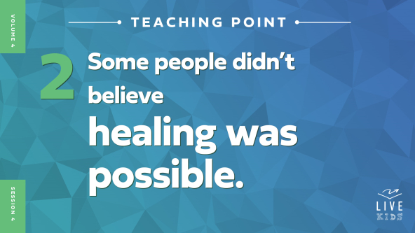

• *Read* [*Mark 5:35*](https://ref.ly/logosref/Bible.Mk5.35)*.*

Wow! Jairus’ faith in Jesus was really put to the test. Instead of hurrying straight to Jairus’s house to help the sick girl, Jesus stopped to help another person who was sick. Do you think Jairus may have been frustrated by that? *(Group response)* Maybe so.

Then Jairus got some terrible news. Messengers from his house came to tell him that his daughter had died. They said he should just give up and not bother Jesus anymore. The messengers thought it was too late. Jesus might have been able to heal sick people, but what could He do for a dead person? Death felt too final, too powerful, even for Jesus.

Imagine what it would be like to hear this terrible news. Everyone around you thinks it’s too late and you should give up hope. Do you think it would be hard to trust that Jesus could still do a miracle? *(Allow responses.)* It would be harder to believe Jesus could bring someone back to life than to believe Jesus could heal someone who was still alive. The Bible tells us Jesus healed a lot of people, but it only tells us about three people He raised from the dead.

Let’s think about the blindfold and the candy bar again. It was pretty easy for *(volunteer’s name)* to believe me when I said I had a candy bar for them. Would it have been harder if everyone in the audience was yelling that I was lying and there wasn’t a candy bar? *(Group response)* Absolutely! That would make it almost impossible to trust me. Well, that’s the place Jairus was in. The people around him said the problem was hopeless—but Jesus said something different.

**3. Jesus told Jairus to trust Him even though it was hard.**

• *Show the* ***Teaching Point 3 Slide.***

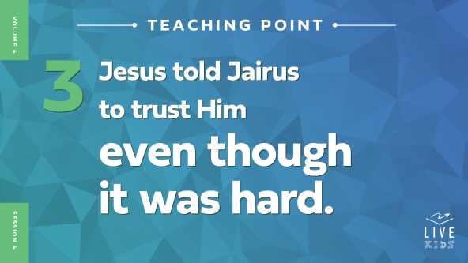

• *Read* [*Mark 5:36–43*](https://ref.ly/logosref/Bible.Mk5.36-43)*.*

Jesus heard what Jairus’ messengers were saying. Do you remember what Jesus said to help Jairus focus on Him? *(Group response)* If you were Jairus, how would you respond to Jesus? *(Allow responses.)*

Jesus didn’t let the crowd of doubters keep walking with Jairus and Him. Instead, Jesus only brought His three closest disciples: Peter, James, and John. As they got closer to the house, Jesus saw people crying and told them the child was only asleep. The crowd heard what He said and laughed. Can you imagine laughing at Jesus like that? *(Group response)* So Jesus made everyone leave except Jairus, Jairus’s wife, and Peter, James, and John. Then they went into the room where the girl was lying.

When Jesus held the girl’s hand and told her to get up, what happened? *(Group response)* She instantly stood up and started walking around! Everyone, show me how you would have reacted if you saw this incredible miracle. (*Allow responses.)* The Bible says Jairus, his wife, and the disciples were overwhelmed and totally amazed. Jairus had believed Jesus could heal his daughter, but it was another thing to see it happen! It was like his blindfold had been taken off. He’d had faith in Jesus’ power, and then he saw the miracle with his own eyes.

**Prayer and Response**

*Consider playing a worship song softly in the background while kids pray.*

I can’t even imagine how hard it was for Jairus to keep his faith in Jesus. His child had died, which is one of the hardest things anyone could go through. And lots of people thought it was impossible for Jesus to do anything about it. They even laughed at Jesus. But then Jesus stepped in and changed everything.

• *Give an index card and a pencil or pen to every kid.*

Remember, the best way to keep your faith is by focusing on Jesus instead of the problem you’re facing. What hard situation are you facing right now? Things always seem harder when we try to face them on our own. Take a moment to write down or draw a problem you need Jesus’ help with. When you’re ready to trust Jesus with your situation, come and place your card in the basket.

• *Give kids time to complete their cards. Encourage kids to remain quiet and respectful during this time.*

Let’s pray and tell Jesus that we trust Him to take care of us and what we’re going through.

• *Optional: Invite kids to pray with a leader about their situation.*

**Prayer**

*Optional: Have the kids repeat phrases of the prayer after you.*

|  |
| --- |
| *Dear Jesus, thanks for showing me that You can do the impossible. Help me to focus on You instead of the problems I’m facing. I want to trust You even when it’s hard. Amen.* |

**Faith Verse**

Our Faith Verse reminds us to trust God no matter what. We don’t always understand what He’s doing, but we can trust He will always be with us. Let’s say our verse together.

• *Play* ***Faith Verse Video****.*



[Proverbs 3:5–6](https://ref.ly/logosref/Bible.Pr3.5-6)

Trust in the Lord with all your heart; do not depend on your own understanding. Seek his will in all you do, and he will show you which path to take.

There are no exceptions in our Faith Verse. It doesn’t say, “Trust in the Lord with all your heart unless you’re too scared” or “unless you move to a new city” or “unless someone you love gets sick.” No, God wants us to trust Him no matter what—with every problem we’re facing.

**Faith Fact**

Before we move on, let’s review our Faith Fact again. **I will trust Jesus even if it’s hard.**

• *Show the* ***Faith Fact Slide****.*



Our Faith Fact is so important! Let’s say it together a couple of more times. **I will trust Jesus even if it’s hard.** Now, say it as loud as you can if you really believe it! **I will trust Jesus even if it’s hard.** Maybe you’re going through a hard time right now. Or maybe your life is going great. Either way, God wants you to trust Him and keep your faith in Him to help you.

• *Dismiss kids to Small Group time or to go home if your group time ends here.*

**Small Group**

**30 Minutes**

*This section can be done in conjunction with the large group or on its own if you do small groups with your kids. During Small Group time, the goal is to connect the kids with the Word of God and to each other. All activities are led by the small group leader.*

**Group Connection**

**Human Knot**

|  |
| --- |
| ***You Will Need***   * *Yarn or string* * *Scissors*   ***Getting Ready***   * *Cut yarn into approximately two-foot lengths, one piece per kid.* |

Jesus wants us to hold tightly to our faith and trust in Him even when our problem seems impossible. We’re going to try something that may seem impossible, too. But no matter what, don’t let go!

• *Give every kid a piece of yarn.*

Let’s create a human knot. Here’s how it works. Everybody will stand in a circle and hold the end of a piece of yarn in one hand. You’ll hold that arm out in the middle of the group. Then with your other hand, you’ll grab the end of someone else’s yarn. Just make sure you don’t pick the yarn of the person next to you.

• *Pause while kids do this step.*

Here comes the hard part! Everyone, keep holding the yarn tightly in your hands while you try to untangle the human knot. Do you think you can do it? *(Group response)* Give it a try!

• *Make sure the kids do not let go of their yarn pieces during the game. Encourage them to work together to untangle the human knot.*

• *Play again if you have time or if it doesn’t work the first time.*

Did that feel impossible at first? *(Group response)* Even when problems we face seem too big to handle, Jesus can do the impossible. So hold on tightly to your faith no matter what and keep trusting in Him.

**Bible Lesson Recap**

• *If small group activities are not immediately following large group time, you may want to read the Bible story passage before the discussion.*

|  |
| --- |
| ***You Will Need***   * *Bibles for kids in the group to share*   *No prep is needed for this activity.* |

**Bible Story Review: A Religious Leader’s Daughter Is Raised from the Dead** [**Mark 5:21–24**](https://ref.ly/logosref/Bible.Mk5.21-24)**,** [**35–43**](https://ref.ly/logosref/Bible.Mk5.35-43)

Jesus was surrounded by a crowd when a man named Jairus asked for His help. Jairus was a leader in the local synagogue, and his daughter was so sick that she was dying. Jairus begged Jesus to come and heal her. Jesus started walking with Jairus toward his house.

Along the way, Jesus stopped to heal a woman who also was very sick. While Jesus was still speaking to her, some messengers arrived to tell Jairus the sad news that his daughter had already died. They didn’t think he should bother Jesus anymore, because it was too late. The girl was already dead. But Jesus told Jairus to keep believing. Jesus went in Jairus’s house to see the girl even though she was already dead. Even when the crowd laughed at Jesus, He didn’t stop what He was doing. Jesus simply told the girl to get up, and she immediately came back to life. Jairus had faith in Jesus, and Jesus raised his daughter from the dead.

• *Optional: Give each kid a Bible and read the Bible story together.*

**Group Discussion**

*Feel free to use all or just a few questions as a jumping-off place for good discussion. Questions marked with * are designed for more conversation. Adjust the questions based on the age or maturity of your group. Typically, older kids will be able to dive a little deeper than younger ones.*

**Questions**

How do you think Jairus felt when he begged Jesus for help that day?

What did Jairus ask Jesus to do?

How do you think Jairus’s feelings changed when he found out his daughter had died?

Do you think it was harder for Jairus to hold onto his faith after his daughter had died? Why or why not?

How do you think Jairus’s family was changed because of Jesus’ miracle?

How might the crowd that laughed at Jesus have changed their thinking if they saw the girl alive and well after Jesus healed her?

* How do you respond when things get hard in your life?

* Is it easier for you to trust God when things are going well or when things are hard? Why?

* How can you tell when others have faith in God no matter what they’re facing?

**Live It**

**Faith Fact**

Our Faith Fact today is **I will trust Jesus even if it’s hard.** Say that with me one more time. **I will trust Jesus even if it’s hard.** Jairus trusted Jesus even when things seemed impossible. That takes strong faith in Jesus! We can’t avoid hard times just because we follow Jesus, but we can continue to trust Him when the hard times come.

**Challenge**

If you face problems this week, I challenge you to pray before doing anything else. Trust Jesus to handle your problem. Many times, the first thing we do is to try to fix the problem ourself or ask someone else to fix it for us. But God wants us to go to Him first, not last.

**Prayer**

*Finish group discussion by sharing prayer requests and praise reports. Keep track of your small group’s prayer requests and review them each time you meet.*

• *Have kids share and pray for each other’s prayer requests.*

|  |
| --- |
| *Dear Jesus, help me trust You no matter what. When I face hard times, help me turn to You before I do anything else. Help me to not give up believing in You. Amen.* |

**Faith Verse Review**

|  |
| --- |
| ***You Will Need***   * *Ball, one per group* * *Large space to play in*   *No prep is needed for this activity.* |

Our Faith Verse is [Proverbs 3:5–6](https://ref.ly/logosref/Bible.Pr3.5-6). This verse reminds us to trust God no matter what life throws our way.

• *Show* ***Faith Verse Video****.*



[Proverbs 3:5–6](https://ref.ly/logosref/Bible.Pr3.5-6)

Trust in the Lord with all your heart; do not depend on your own understanding. Seek his will in all you do, and he will show you which path to take.

Who thinks they have the Faith Verse memorized? *(Group response)* That’s great to hear! This is the last time we’ll be saying on it together.

• *Say the verse as a group a couple of times.*

**Faith Verse Fun**

**Keep-Away Tag**

Let’s play Keep-Away Tag to review the Faith Verse. I’m going to toss a ball to one of you to get the game started. Right after you catch the ball, start saying the Faith Verse while you run away from the rest of the group. Everyone else will try to tag the person with the ball before they finish saying the Faith Verse. If you tag them, you’ll get the ball and begin saying the Faith Verse as you run away from the rest of the group. Let’s see who can say the whole Faith Verse before being tagged. Are you ready to play? *(Group response)*

• *Keep playing until someone says the Faith Verse before being tagged.*

• *Play more rounds if desired.*

That game was so much fun, and I hope it helped the Faith Verse stick in your mind. Keep saying [Proverbs 3:5–6](https://ref.ly/logosref/Bible.Pr3.5-6) every day to make sure you don’t forget it. It’s such a powerful part of God’s Word. You can use it for the rest of your life to remember to trust God.

**Activity Page**

**Draw the Impossible**

|  |
| --- |
| ***You Will Need***   * ***Small Group Activity Page****, one per kid* * *Pencils or pens, one per kid* * *Crayons or markers*   ***Getting Ready***   * *Print copies of the* ***Small Group Activity Page****, one per kid.* |

We’ve talked a lot about having faith in impossible situations today. Let’s write or draw about one problem like that on our Activity Page.

• *Hand out a copy of the* ***Small Group Activity Page,*** *a pencil, and crayons to each kid.*

Take a little time to write or draw your responses to the questions on the page.

• *Talk with individual kids about what they have drawn.*

**Dismissal**

When Jesus raised Jairus’s daughter from the dead, it was unexpected and seemed impossible. But Jairus had faith in Jesus no matter what. Think about the impossible situation on your Activity Page. Let’s pray and ask Jesus to do a miracle for you and help you hold tightly to your faith while you’re waiting.

**Prayer**

|  |
| --- |
| *Dear Jesus, thank You for always being with us. We know You can do the unexpected and impossible for us just like You did for Jairus and his daughter. Help us to keep our faith in You even when life gets hard. Please help us with the problems we’re facing. Please do miracles for us. We trust You. Amen.* |

**Faith Fact Recap**

• *Show the* ***Faith Fact Slide****.*



Our Faith Fact is a great reminder to keep believing in Jesus no matter what. Say it with me. **I will trust Jesus even if it’s hard.** Jesus does unexpected things and fixes impossible problems. That’s a powerful thought to take with us as we leave today. See you next time!

• *Send home the* ***Small Group Activity Page.***

• *Remind parents that there are* ***Family Devotions*** *available on the app to do with their kid.*

• *Tell everyone the date and time for the next session.*

.